**Pre-model activity**

G. Chandra Sekhar

192211135

1. Write a c++ program to create a class room has private data member company, model and year implement this member function.

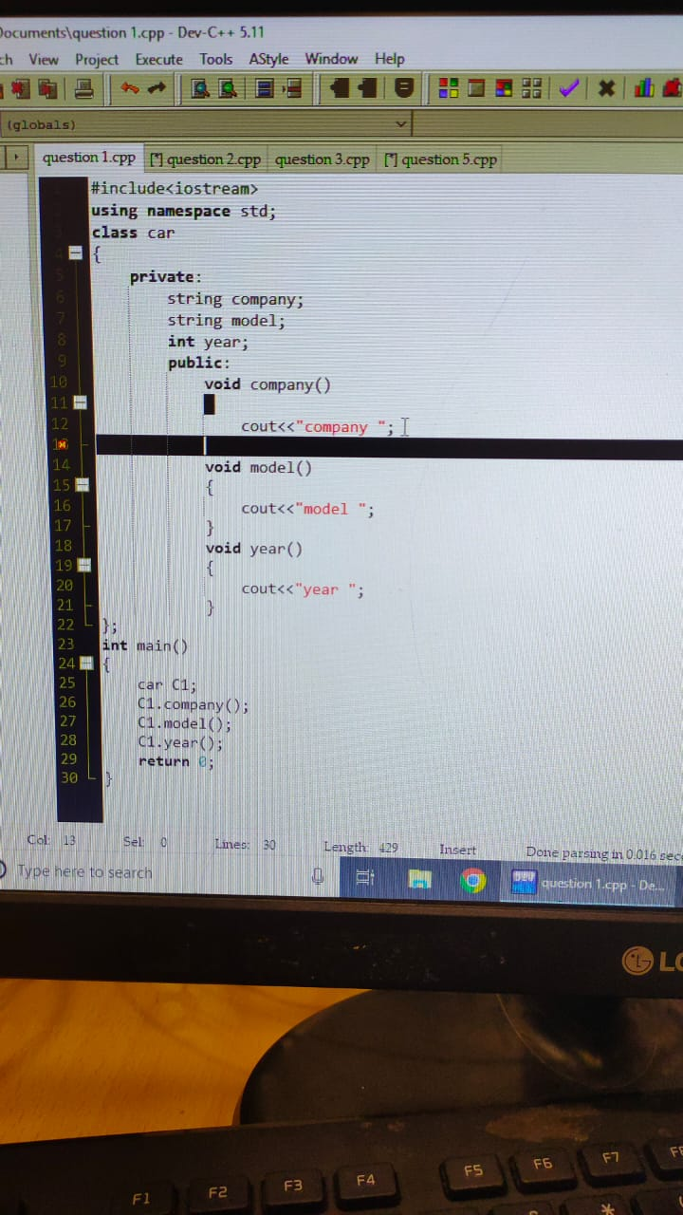

1. Write a c++ program for Class name programming while creating an object of class if nothing is passed through it then the message will be “I like programming language” should written if some string is passed through it then print string and “I like programming language”.

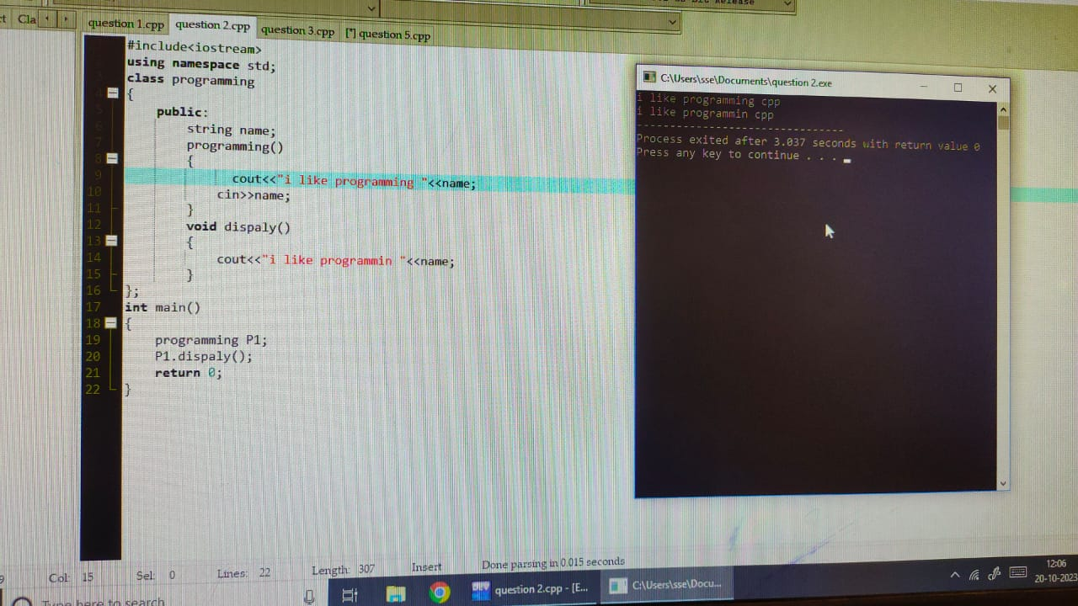

3.Write a c++ program for a pattern

1

1 2

1 2 3

1. 2 3 4

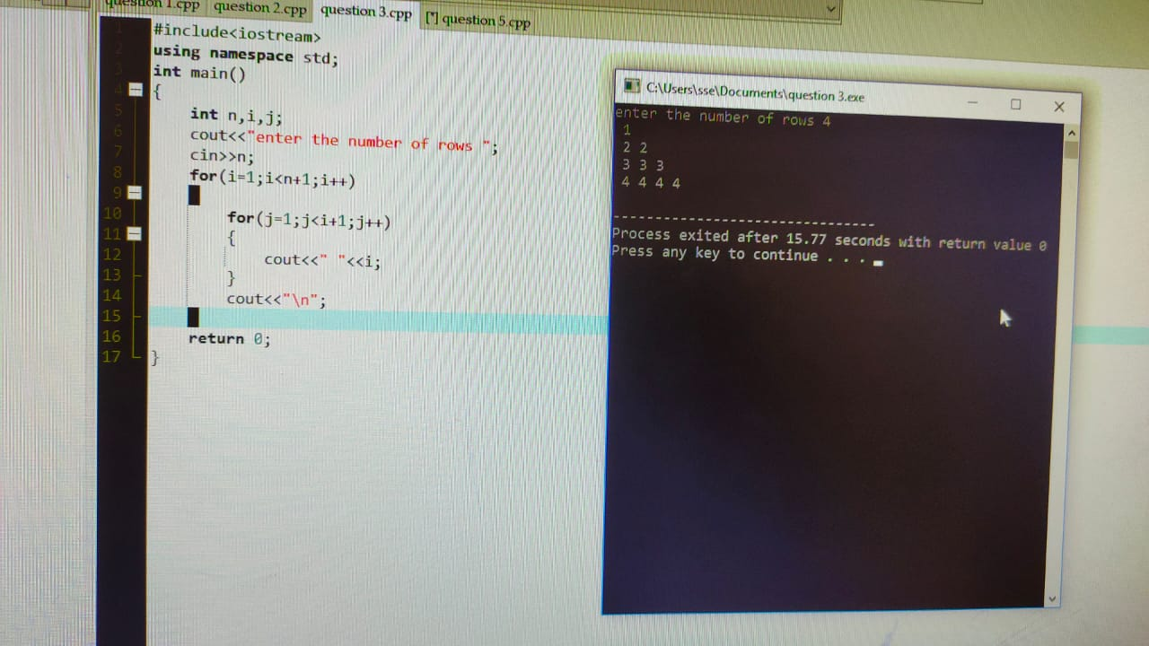

4. Write a c++ program for Base class building has data member number of units consumed customer name and another class apartment derived class for building has data member number of floors, number of houses/flats. If floors are above 3 or 10 means unit rate is 10 or else unit rate 5 calculate amount.

